William Mackay
MTH 337, Professor Adam Cunningham

Weekly Report 08
Introduction
This report explores the generation and applications of random numbers in science and mathematics. Random numbers are very useful in simulating systems with stochastic elements, function integration, and estimation, among other things. Unfortunately, because computers are deterministic systems, “random” numbers generated by a computer are only pseudo-random. This can lead to biases and errors. In order to better understand this phenomenon and its implications, two variants of a linear congruential generator were written in Python for part 1 of this report. The uniformity and pairwise correlation of these two pseudo-random number generators were compared against those of numpy's built-in rand function.
One of the important uses of random numbers is characterizing functions that are unknown but whose value at any x can be found. By evaluating the function at a large number of random points in an interval, the mean of the function on that interval can be approximated. In order to demonstrate this, for the second part of this report, a function “mysteryf” was evaluated at many random x values generated using Python's rand function and then averaged.
Similarly, random numbers can be used to estimate the area of a curve. In polar coordinates, the area enclosed by a curve can be estimated by generating a large number of random points in a square enclosing the curve. The ratio of points inside the curve to the total number of points should give a good approximation of the curve's area relative to the area of the square circumscribed around it. This is done for the function r=2+cos(7θ) in part 3 of this report.
Random numbers can also be used to numerically simulate Bernoulli random variables, or random variables with two possible outcomes. In part 4 of this report, this principle is used to estimate the probability of getting exactly 29 out of 100 baseball hits when the probability of getting a hit is 29%.
The behavior of the sums of sets of random numbers is also examined in this report. In part 5 of this report, the sums of 2-8 random numbers are plotted on a histogram to examine their behavior as the number of sets in the sum increases and to see if the converge to some shape as the number of sets summed, M, approaches infinity. This is also done for non-uniform random numbers generated using a probability density function.
The last exercise covered in this report is a simulation of the stock market using random elements in a normal distribution. The simulation is run many times to determine the most likely outcome of investing money for 1 year in a volatile market and then a less volatile market.
Approach
Part 1:
For this section of the Python script, two functions were written, RNG and randu. These functions are linear congruential generators. A linear congruential generator generates random numbers using a seed number k and applying the equation k = a·k mod m, then dividing the new k by m to get x_{k}, a pseudo-random number. a and m are typically very large numbers. In the case of RNG, a and m were 427419669081 and 999999999989, respectively. In the case of randu, a and m were 2¹⁶+3 and 2³¹, respectively.
Part 2:
The function mysteryf was averaged using the function mysteryf_mean. This function generated a sample of random numbers of size n (chosen by the user) using Python's rand function. The array had to be multiplied by 5 so that the numbers were in the interval [0,5] as opposed to [0,1]. A new array was then generated by evaluating the function at each random number. This array was then averaged to approximate the mean of the function on the interval [0,5] using numpy's mean function. The output of mysteryf was also plotted for a sample of random points in order to observe the shape of the function.
Part 3:
The function r=2+cos(7θ) was integrated in polar coordinates by generating a two large samples of random numbers in the range [-3,3] (x and y coordinates) and converting the pairs into polar coordinates (r and θ) to create a bounding square. The number of points inside the curve was determined by checking the r component against that of the function at the same value of θ from the random set of polar coordinates. The ratio of the number of points inside the function to the total number of points was multiplied by the total area of the bounding square to get the approximate area of the function.
Part 4:
In order to estimate the probability of scoring exactly 29 out of 100 hits in baseball when the probability of getting a hit is 29%, a function batting_trials was written. This function took as inputs the number of swings (100), number of hits (29), number of trials, and the probability of a hit (29%). It then generated an n by m array of random numbers where n was the number of trials and m was the number of swings in each trial. The number of hits in each trial were then summed and each trial in which the desired number of swings were hits was counted. The number of trials in which there were exactly 29 hits was then counted and divided by the total number of trials to get the probability.
Part 5:
In this part, M sets of random numbers of size n were generated and then summed element by element to get a single 1 by n array for values of M from 2 to 8. Histograms for each of these sums were generated and plotted on the same figure. The histograms were then plotted on a different figure and scaled and shifted to see if they converged to the same shape as M increased. First, all of the arrays were shifted by subtracting their respective mean values, ensuring that they were all distributed about the same point (0). Finding the scaling factor required some experimentation. It was known that the scaling factor would be a function of M between 1 and M. Fractions of M, such as M/2 and M/4 were tested and did not produce favorable results. Then, powers of M were tested. It turned out that when the arrays were divided by M^{1/2}, the distributions all converged to the same shape. The sums of non-uniform random numbers were also tested. Using a probability density function of p(v)=(5/32)v⁴, the function g(u)=2u^{1/5} was found by integrating p(v), setting it equal to u, and solving for v. g(u) was then applied to a set of random numbers u and plotted as a histogram along with p(v). Once it was confirmed that the non-uniform distribution was behaving properly, sums of the non-uniform distributions for M from 2 to 8 were plotted on the same figure.
Part 6:
For this part of the script, a function stock_sim was written that took as inputs the initial value of the stock, the time that was to be simulated, the growth rate (μ), the volatility (σ), and the number of trials. For the purposes of this simulation, the growth rate was set to 0. The volatility represented the effect of random variations on the price of stock and was initially set to 0.05. The price of stock at a given time step was calculated using the equation s_{i+1}=(1+μ+σε)s_{i}, where epsilon was a random number between 0 and 1 generated using numpy's normal function. This function generates normally distributed random number. 5 trials of the simulation were plotted so that the behavior of the simulation could be observed. The final prices after a large number of trials were also plotted on a histogram and averaged to obtain the expected value of the stock after 1 year. The probability of losing money was calculated by dividing the number of trials in which the final price was less than 1 by the total number of trials. These operations were also performed for a simulation with a more conservative value of σ (0.01).
Results
Part 1:
The histograms and pairwise correlation plots in figures 1 through 6 were obtained from the RNG, randu, and rand functions.
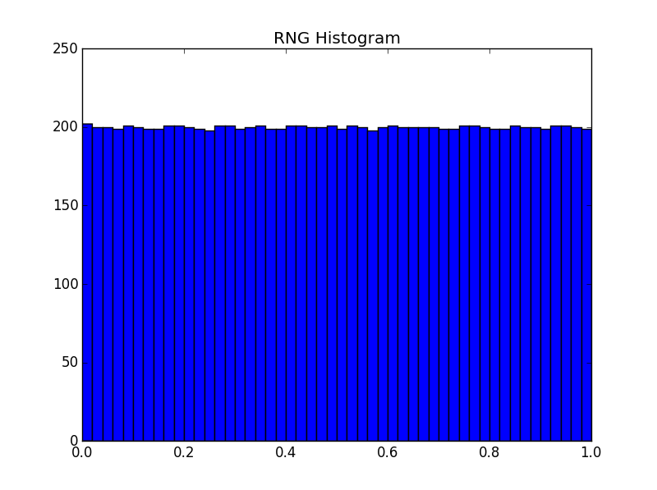Figure 1
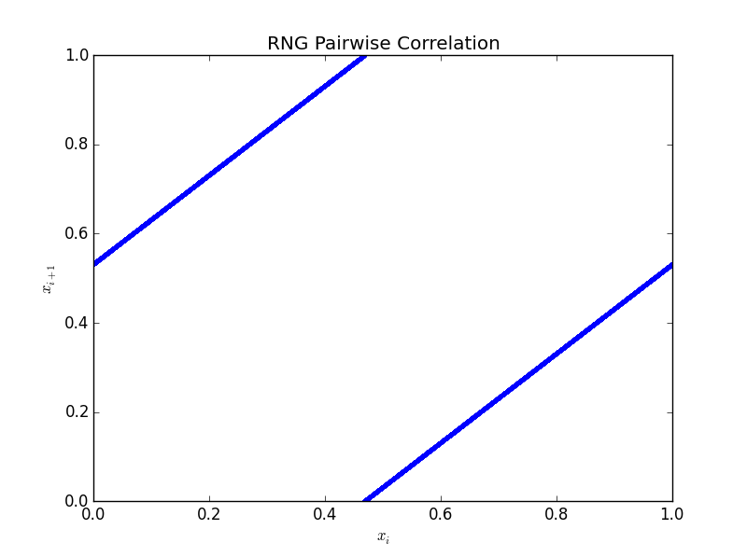Figure 2
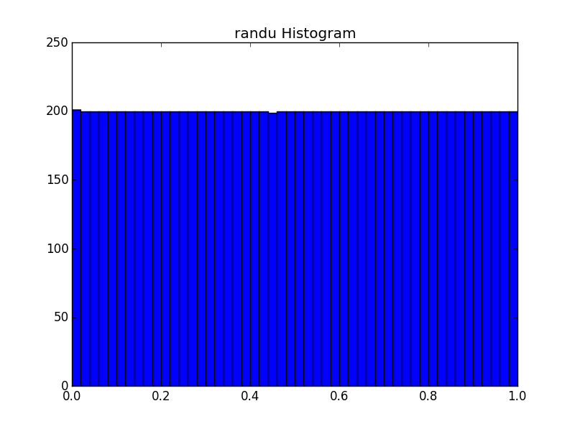Figure 3
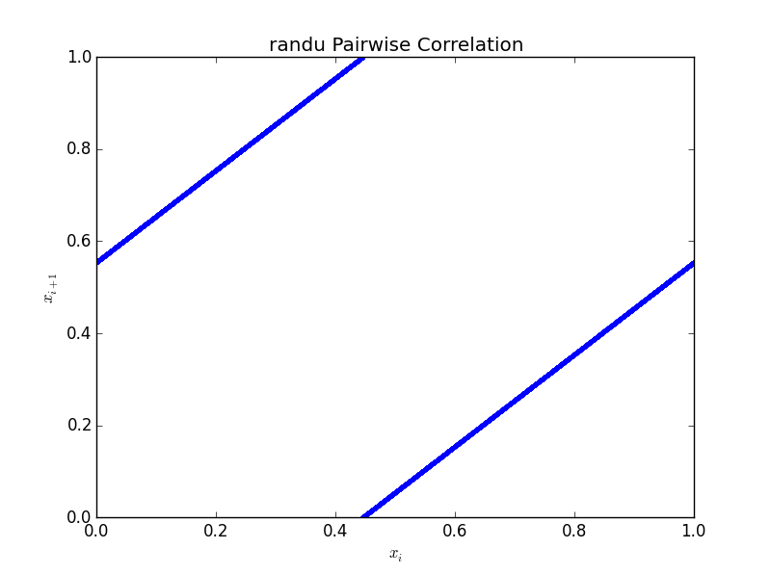Figure 4

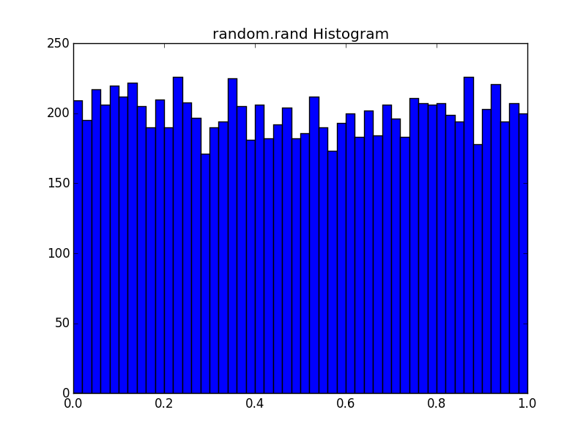Figure 5
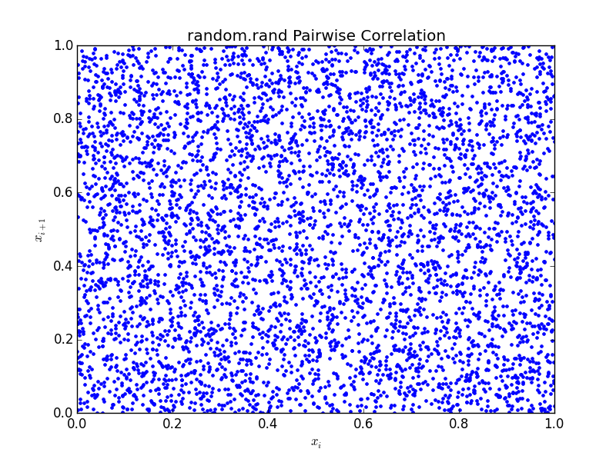Figure 6

Part 2:
The mean of the function mysteryf was approximately 68.8696 on the interval [0,5]. This varied by a few tenths over multiple runs. The plot of mysteryf for random inputs is shown in figure 7.
Part 3:
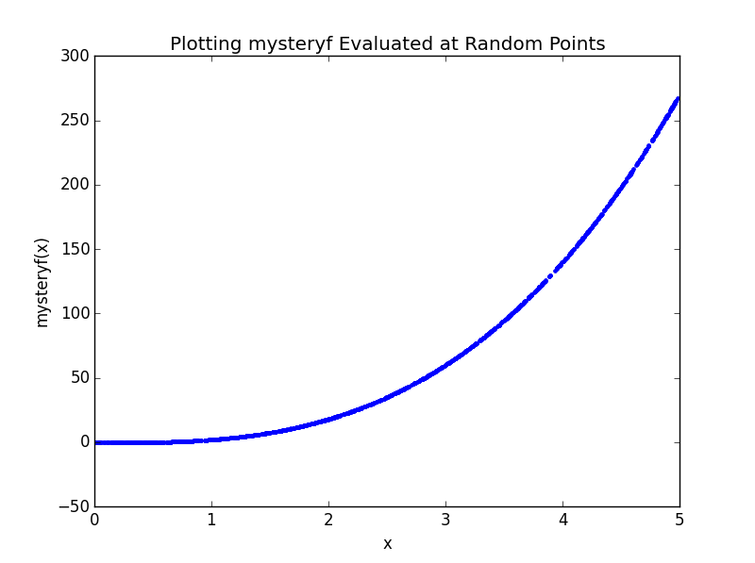Figure 7
The approximate area of the curve was 14.0796. This value varied by a few tenths at most on successive runs of the simulation. Figure 8 shows the curve and random points in the bounding square.
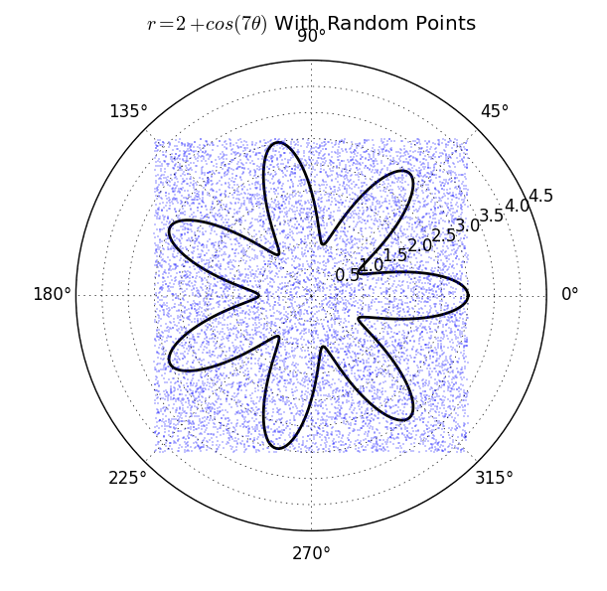Figure 8
Part 4:
The probability of scoring exactly 29 hits in 100 swings is approximately 0.0934. This value varied by a few thousandths on successive runs.
Part 5:
Figures 9 and 10 are the unscaled and scaled histograms of the sums of M-tuples of random numbers for M from 2 to 8, respectively. Figure 11 is a plot of p(v) and a histogram of g(u) for many random values of u. Figure 12 is the set of histograms for M-tuples of non-uniform random numbers generated by g(u) for M from 2 to 8.
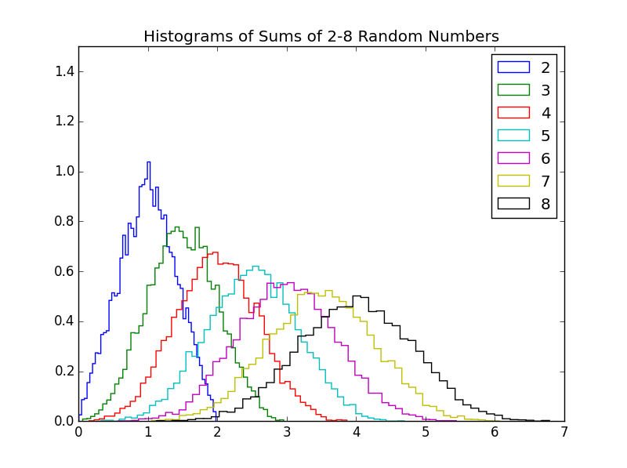Figure 9

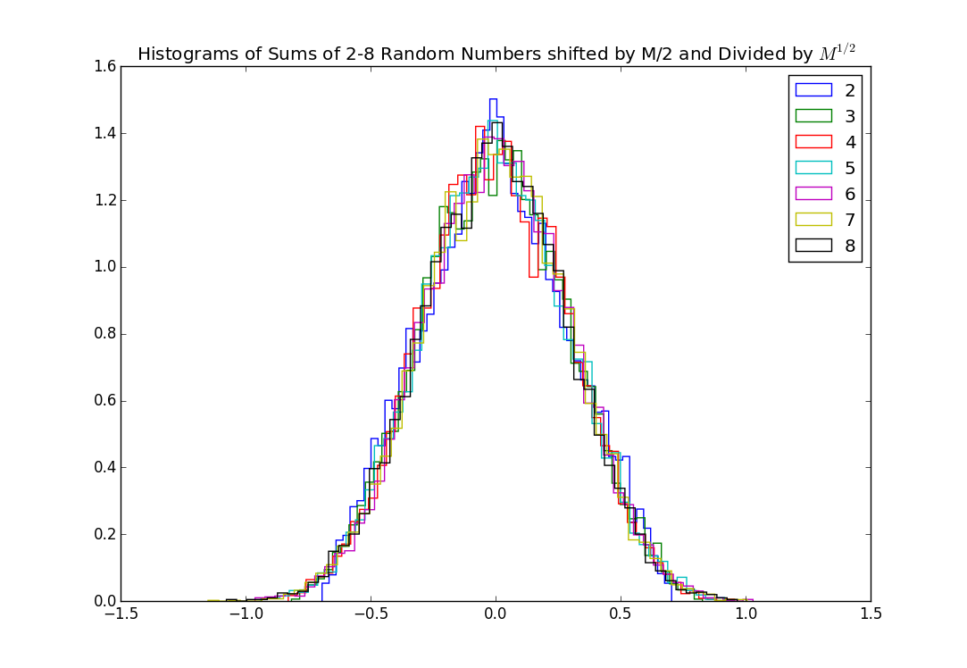Figure 10
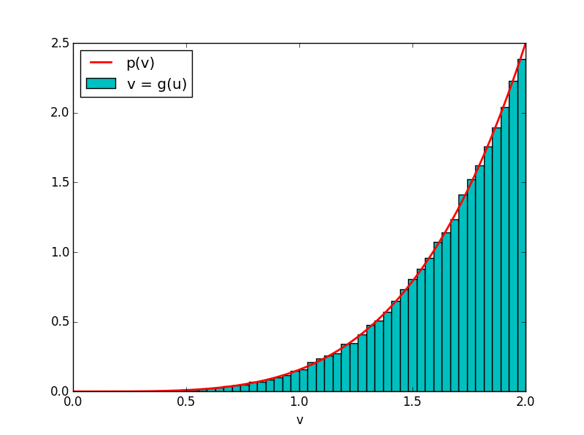Figure 11

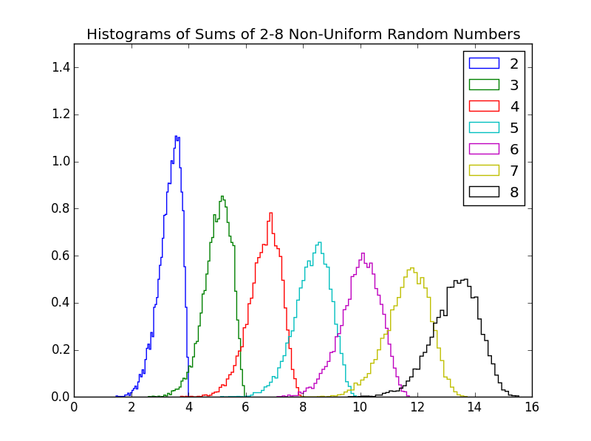Figure 12
Part 6:
The probability of losing money when the σ was 0.05 was 0.6814. The expected value was 0.9985. When σ was 0.01, the probability of losing money and the expected value were 0.5381 and 0.9999, respectively. Figure 13 is a plot of five different runs of the function stock_sim. Figures 14 and 15 are histograms of the final stock prices for both σ values.
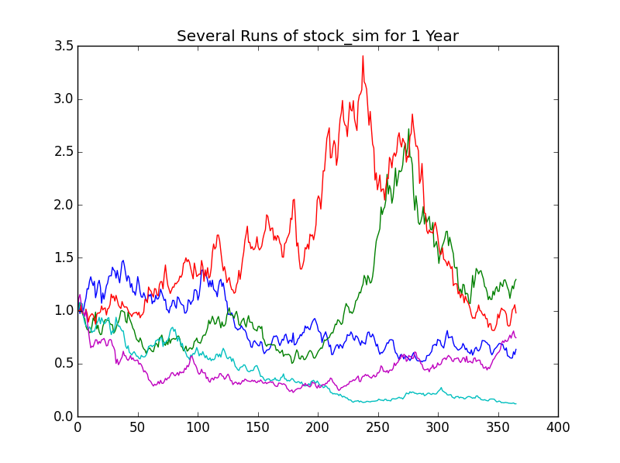Figure 13
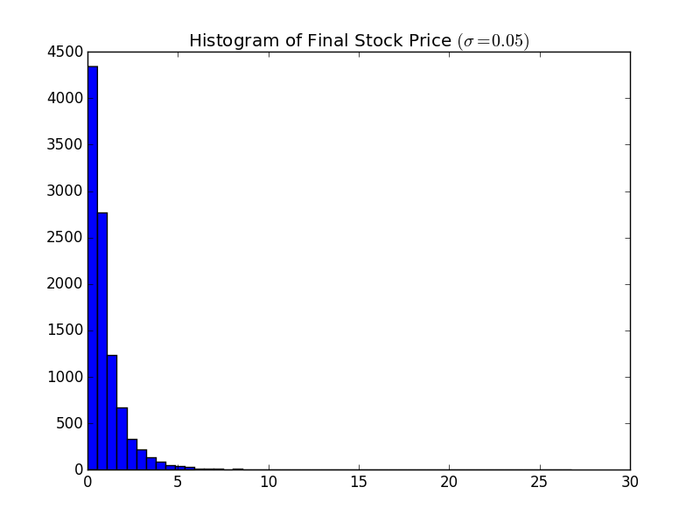Figure 14

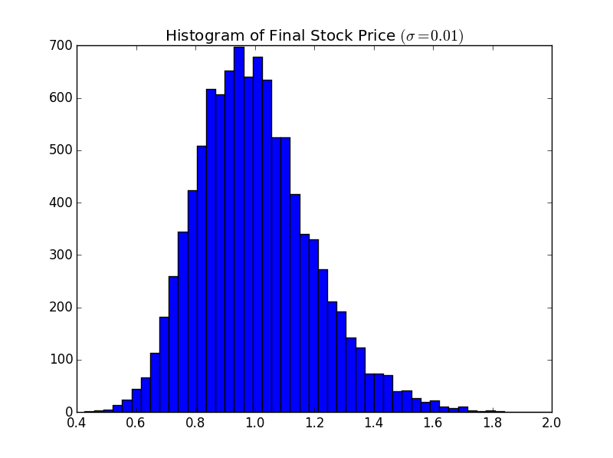Figure 15

Conclusion
Part 1:
Both RNG and randu produce very uniform sets of random numbers for a large range of seed values, with randu producing a slightly more uniform set of random numbers. From the histograms, in figures 1 and 3, there seem to be almost an equal number of values in each “bin” for both generators. Unfortunately, from figures 2 and 4, it is possible to see that there is very pronounced pairwise correlation between successive values produced by these two functions. Both functions seem to exhibit cyclical behavior in generating random numbers, which would explain the uniformity. This indicates that successive values of RNG and randu are not entirely independent of the previous one. The random.rand function generates a somewhat less uniform distribution of numbers, but successive values have no apparent dependence on previous ones.
Part 2:
From the plot in figure 7, mysteryf appears to be some sort or exponential or polynomial function. The average that was calculated using Monte Carlo integration appears sensible given the magnitudes of the values of the function in the interval. The maximum value of the function in the interval is almost 275, but the function is below 68 for most of the tested domain.
Part 3:
The “flower” produced by the function r=2+cos(7θ) appears to take up the minority of the space in the bounding square (A=6·6=36), meaning that the area of approximately 14 appears sensible. In order to test whether this area was accurate, the function was integrated from 0 to 2π to get the area analytically. This integral was equal to 4π, or approximately 12.57, meaning that the script over-estimated the area enclosed by the curve.
Part 4:
From the python script, the chances of getting exactly 29 hits was about 9%. From probability theory, for a Bernoulli random variable, the probability of x successes in n trials when the probability of success in any trial is P is. When this formula is applied to this particular situation, where n=100, x=29, and P=0.29, the result is 8.76%, which is very close to the answer obtained from the Python script. Interestingly, the random variable in this situation is not exactly a Bernoulli random variable as there are more than two outcomes for any trial. The batter could hit, miss, hit a foul, or be hit by the ball.
Part 5:
As M increases, the distribution appears to more closely resemble a normal distribution for both uniform and non-uniform random numbers. When the M-tuples are shifted by M/2 and divided by M^{1/2}, they converge to the same normal distribution centered about 0 with a maximum value of 1.4. It is important to note that the sets were normalized before they were plotted as well. It was interesting that even non-uniform distributions converged to a normal distribution, though more slowly.
Part 6:
For both values of σ, the expected value was effectively 1, or the staring value. This makes sense given that the growth rate μ was set to 0. Interestingly, despite the expected value being 1 when σ was 0.05, the probability of losing money was greater than 50%. This is most likely because, with the large amount of volatility, it was possible to lose one's initial investment quickly but there was a lot of potential for growth. When the volatility was smaller, the chance of losing money decreased to close to 50%.

Python Code
#William Mackay
#MTH 337 Assignment 8

from pylab import *

n=10000

#Part 1 - Random Number Generation

def RNG(k, a=427419669081, m=999999999989):
k=a*k%m
xk=k/m
return xk

def randu(k, a=2**16+3, m=2**31):
k=a*k%m
xk=k/m
return xk

#Histogram for uniformity of RNG
k_rng=linspace(1,999999999989,n)
x_rng=RNG(k_rng)

figure (1)
hist(x_rng,50)
title('RNG Histogram')

#Testing for pairwise correlation in RNG
figure(2)
plot(x_rng[0::2],x_rng[1::2],'b.')
title('RNG Pairwise Correlation')
xlabel('$x_i$')
ylabel('$x_{i+1}$')

#Histogram for uniformity of randu
k_randu=linspace(1,2**31,n)
x_randu=randu(k_randu)

figure (3)
hist(x_randu,50)
title('randu Histogram')

#Testing for pairwise correlation in randu
figure(4)
plot(x_randu[0::2],x_randu[1::2],'b.')
title('randu Pairwise Correlation')
xlabel('$x_i$')
ylabel('$x_{i+1}$')

#Testing random.rand
x_rand=rand(n)

figure (5)
hist(x_rand,50)
title('random.rand Histogram')

figure (6)
plot(x_rand[0::2],x_rand[1::2],'b.')
title('random.rand Pairwise Correlation')
xlabel('$x_i$')
ylabel('$x_{i+1}$')

#Part 2 - Finding the Mean of mysterf Using Monte Carlo Integration
print "PART 2"

from mystery import mysteryf

x=5*rand(1000)
y=mysteryf(x)

figure (7)
plot(x,y,'b.')
title('Plotting mysteryf Evaluated at Random Points')
xlabel('x')
ylabel('mysteryf(x)')

def mysteryf_mean(n):
x=5*rand(n)
y=mysteryf(x)
y_avg=mean(y)
return y_avg

y_avg=mysteryf_mean(n)
print "The mean of mysteryf in the range [0,5] is",y_avg

#Part 3 - Monte Carlo Integration of a Polar Function
print "PART 3"

theta=linspace(0,2*pi,400)
r=2+cos(7*theta)

#Defining box enclosing function
x=6*rand(n)-3
y=6*rand(n)-3
total_area=6**2

#Converting to polar coordinates
theta2=arctan2(y,x)
r2=sqrt(x**2+y**2)

#Plotting function and box
figure(8)
polar(theta,r,'k',linewidth=2)
polar(theta2,r2,'b.',ms=1, alpha=0.5)
title(r'$r=2+cos(7\theta)$ With Random Points')

#Finding r of the actual function at each random theta value
rf=2+cos(7*theta2)
#Calculating number of points inside the curve
inside=(rf-r2)>=0
inside=sum(inside)

#Using ratio of points inside to total to find area of the curve
area_ratio=float(inside)/n
area_curve=area_ratio*total_area
print "The area of the curve is approximately",area_curve

#Part 4 - Simulating a Bernoulli Random Number
print "PART 4"

num_swings=100
num_hits=29
p=0.29

def batting_trial(num_swings,num_hits,p,n):
swings=rand(n,num_swings)
hits=swings<p
hits_per_trial=sum(hits,axis=1)
x=float(sum(hits_per_trial==num_hits))
return x/n

prob=batting_trial(num_swings,num_hits,p,n)
print "The probability of getting exactly 29 hits is approximately",prob

#Part 5 - Sums of Random Numbers, and the Central Limit Theorem

figure(9)
ylim([0,1.5])
for i in xrange(2,9):
results=rand(i,n)
totals=sum(results, axis=0)
hist(totals,bins=50, normed=True,histtype='step',label=str(i))
title('Histograms of Sums of 2-8 Random Numbers')
legend()

figure(10)
for i in xrange(2,9):
results=rand(i,n)
totals=sum(results, axis=0)
hist((totals-(i/2.))/(sqrt(i)),bins=50, normed=True,histtype='step',label=str(i))
title('Histograms of Sums of 2-8 Random Numbers shifted by M/2 and Divided by $M^{1/2}$')
legend()

u = rand(n*10)
v = (32*u)**(1./5)
figure(11)
hist(v, normed=True, bins=50, fc='c', label='v = g(u)')
x = linspace(0, 2, 400)
y = (5./32)*x**4
plot(x, y, 'r', lw=2, label='p(v)')
xlabel('v')
legend(loc='upper left')

figure(12)
ylim([0,1.5])
for i in xrange(2,9):
results=(32*(rand(i,n)))**(1./5)
totals=sum(results, axis=0)
hist(totals,bins=50, normed=True,histtype='step',label=str(i))
title('Histograms of Sums of 2-8 Non-Uniform Random Numbers')
legend()

#Part 6 - Stock Market Simulation
print "PART 6"

def stock_sim(s_0,t,mu=0,sigma=0.05,trials=1):
s=empty((trials,t))
s[:,0]=s_0*ones(trials)
for i in xrange(1,t):
epsilon=normal(size=trials)
s[:,i]=(1+mu+sigma*epsilon)*s[:,i-1]
return s

s_0=1
mu=0.000
sigma1=0.05
sigma2=0.01
t_max=365
trials=10000
t=linspace(0,t_max,t_max)
s1=stock_sim(s_0,t_max,mu,sigma1,trials)
s2=stock_sim(s_0,t_max,mu,sigma2,trials)

t=linspace(0,t_max,t_max)
s=stock_sim(s_0,t_max,mu,sigma1,5)

figure(13)
for i in xrange(5):
plot(t,s[i,:],label=str(i))
title('Several Runs of stock_sim for 1 Year')

final_price1=s1[:,364]
EV1=mean(final_price1)
loss1=final_price1<1
p_loss1=float(sum(loss1))/trials
print "Expected Value","(", u'\u03c3',"= 0.05",")","=", EV1
print "Probability of Losing Money =", p_loss1
figure(14)
hist(final_price1,50)
title(r'Histogram of Final Stock Price $(\sigma=0.05)$')

final_price2=s2[:,364]
EV2=mean(final_price2)
loss2=final_price2<1
p_loss2=float(sum(loss2))/trials
print "Expected Value","(", u'\u03c3',"= 0.01",")","=", EV2
print "Probability of Losing Money =", p_loss2
figure(15)
hist(final_price2,50)
title(r'Histogram of Final Stock Price $(\sigma=0.01)$')

show()

